CUSTOMER DATA ANALYSIS USING POWER BI
PRDA – 05 Customer Data Analysis
Internship Project Report

Submitted By- Project ID: Team PTID-CDA-SEP-26-11157 - CDA
DECLARATION
I hereby declare that the project titled "Customer Data Analysis Using Power BI" is an original work carried out by me as part of my internship project. The analysis, dashboard development, findings, and recommendations presented in this report are based on the provided dataset and my understanding of Data Analytics and Business Intelligence concepts.

ACKNOWLEDGEMENT
I would like to express my sincere gratitude to my internship mentor and organization for providing me with the opportunity to work on this project.
This project helped me gain practical knowledge in Power BI, Data Visualization, Business Intelligence, Customer Segmentation, Revenue Analysis, and Dashboard Development. The experience enhanced my technical and analytical skills and provided valuable exposure to real-world business problem-solving.

ABSTRACT
Data analytics plays a vital role in transforming raw business data into meaningful insights. This project analyzes customer shopping behavior across ten shopping malls in Istanbul between 2021 and 2023 using Microsoft Power BI.
The analysis focuses on customer demographics, purchasing behavior, product category performance, revenue generation, and payment preferences. Interactive dashboards were developed to answer business questions and generate actionable recommendations. The insights derived can support business growth, customer engagement, inventory planning, and strategic decision-making.

TABLE OF CONTENTS
- Introduction
- Project Objectives
- Dataset Description
- Data Preparation
- Power BI Implementation
- DAX Measures and Formulas
- Dashboard Overview
- Gender Analysis
- Age Analysis
- Payment Method Analysis
- Key Insights
- Business Recommendations
- Skills Demonstrated
- Conclusion
- References

1. INTRODUCTION
Retail organizations generate large volumes of customer transaction data every day. Understanding customer purchasing behavior is essential for improving sales performance, customer satisfaction, and operational efficiency.
This project uses Microsoft Power BI to analyze shopping transaction data collected from multiple shopping malls. The dashboard helps identify customer trends based on gender, age groups, product categories, and payment methods. The findings provide meaningful insights that support data-driven decision-making.

2. PROJECT OBJECTIVES
- gender generated more revenue?
- Distribution of purchase categories relative to other columns?
- How is the shopping distribution according to age?
- Which age cat did we sell more products to?
- Which age cat generated more revenue?
- Distribution of purchase categories relative to other columns?
- Does the payment How is the shopping distribution according to gender?
- Which gender did we sell more products to?
- Which method have a relation with other columns?
- How is the distribution of the payment method?
- Visualize the data using Tableau /PowerBI and derive insights and give your inputs/suggestions to the company.

3. DATASET DESCRIPTION
The dataset contains customer shopping information collected from ten shopping malls in Istanbul between 2021 and 2023.

Table 1: Dataset Attributes
Attribute | Description
Invoice Number | Unique transaction identifier
Customer ID | Unique customer identifier
Gender | Customer gender
Age | Customer age
Category | Purchased product category
Quantity | Number of products purchased
Price | Product price
Payment Method | Cash, Credit Card, Debit Card
Invoice Date | Date of purchase
Shopping Mall | Shopping mall location
4. DATA PREPARATION
Data Cleaning Activities
- Verified column data types.
- Checked for missing values.
- Removed inconsistencies.
- Validated transaction records.
- Ensured data quality for visualization.
Revenue Calculation
Revenue = Quantity × Price
Age Group Segmentation
Age Range | Age Group
0–20 | Youth
21–30 | Young Adults
31–40 | Adults
41–50 | Mid-Age
51–60 | Mature Adults
61+ | Senior Citizens

5. POWER BI IMPLEMENTATION
Implementation Steps
- Imported dataset into Power BI.
- Performed data cleaning using Power Query.
- Created DAX measures.
- Developed KPI cards.
- Created interactive visualizations.
- Generated business insights.
Dashboard KPIs
KPI | Value
Total Revenue | 2.37M
Total Transactions | 1000
Total Quantity Sold | 2981
Average Orders | 2.37K
Average Revenue | 0.79K

6. DAX MEASURES AND FORMULAS
Total Revenue
Total Revenue =SUMX(Customer_Data,Customer_Data[quantity] * Customer_Data[price])
Total Quantity Sold
Total Quantity Sold =SUM(Customer_Data[quantity])
Total Transactions
Total Transactions =COUNT(Customer_Data[invoice_no])
Average Order ValueAverage Order Value =DIVIDE([Total Revenue],
[Total Transactions])
Age Group
Age Group =SWITCH(TRUE(),
Customer_Data[age] <=20,"0-20",
Customer_Data[age] <=30,"21-30",
Customer_Data[age] <=40,"31-40",
Customer_Data[age] <=50,"41-50",
Customer_Data[age] <=60,"51-60",
"61+")

7. DASHBOARD OVERVIEW
Figure 1: Customer Data Analysis Dashboard
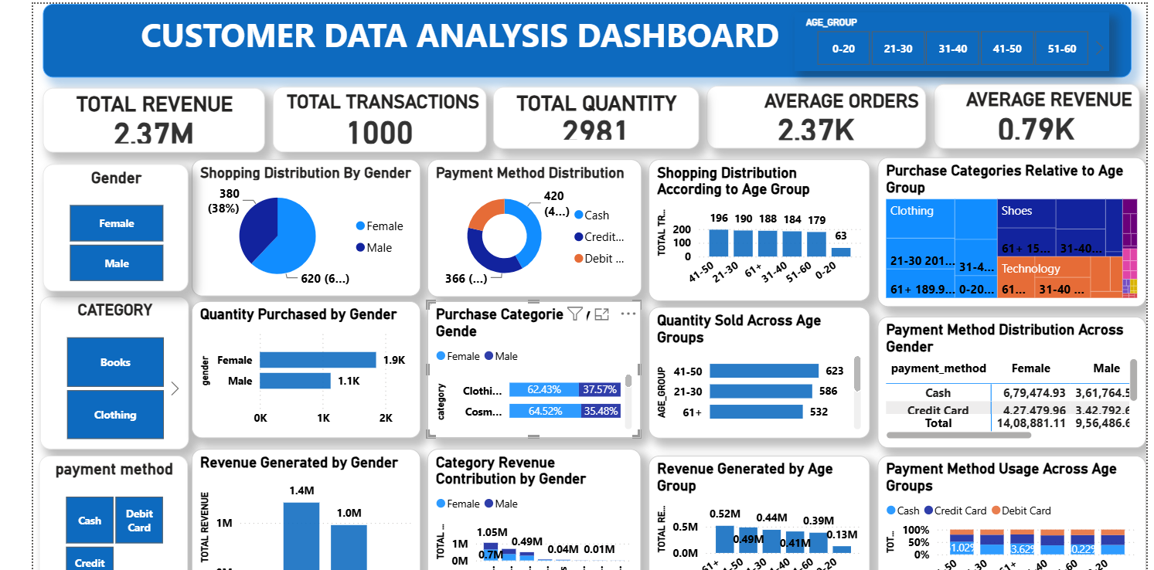
The dashboard provides a comprehensive overview of customer demographics, category performance, revenue generation, shopping distribution, and payment behavior.

8. GENDER ANALYSIS
Table 2: Gender Distribution
Gender | Distribution
Female | 62%
Male | 38%
Observation
Female customers account for a larger share of shopping transactions.
Insight

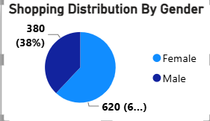
Female customers represent the dominant customer segment and contribute significantly to overall business performance.
Table 3: Quantity Purchased by Gender
Gender | Quantity Purchased
Female | 1.9K
Male | 1.1K

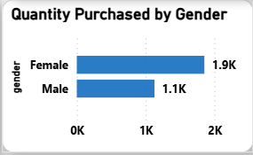

Table 4: Revenue Generated by Gender
Gender | Revenue
Female | 1.4M
Male | 1.0M

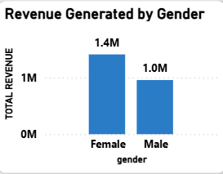

9. AGE ANALYSIS
Table 5: Quantity Sold by Age Group
Age Group | Quantity Sold
41–50 | 623
21–30 | 586
61+ | 532

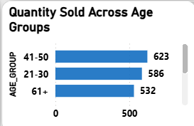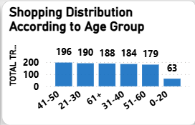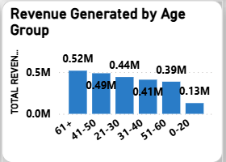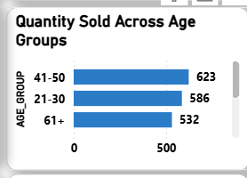
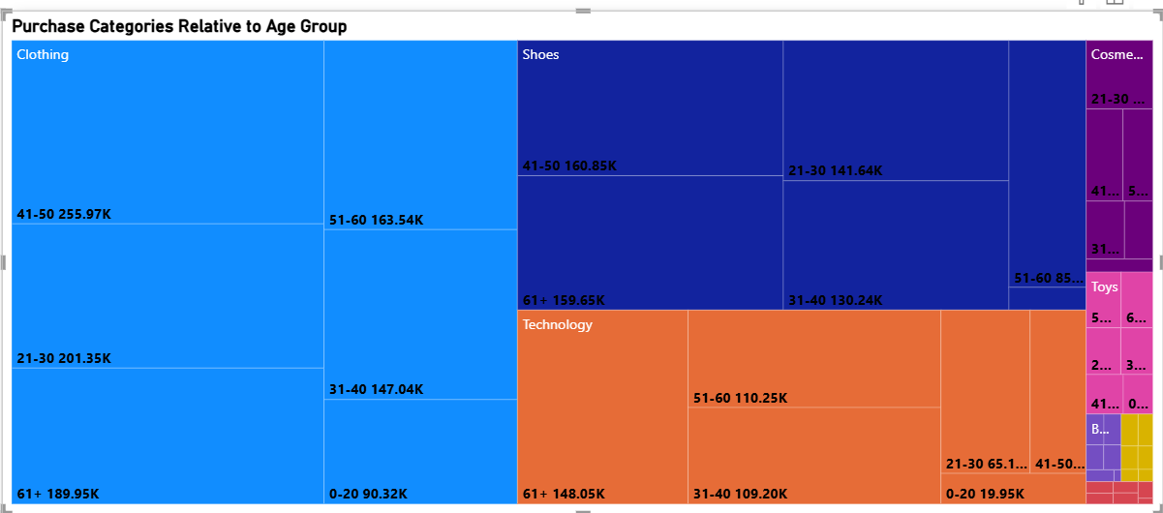
Key Finding
Customers aged 41–50 purchased the highest quantity of products.

10. PAYMENT METHOD ANALYSIS
Table 6: Payment Method Ranking
Rank | Payment Method
1 | Cash
2 | Credit Card
3 | Debit Card

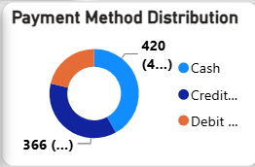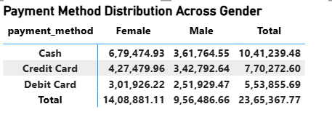

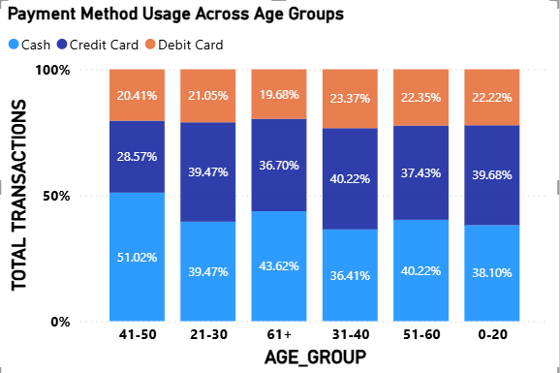
Key Finding
Cash remains the most preferred payment method among customers.

11. KEY INSIGHTS
Customer Insights
✅ Female customers generated higher revenue than male customers.
✅ Female customers purchased the highest quantity of products.
✅ Customers aged 41–50 contributed the highest quantity sold.
✅ Customers aged 21–50 generate the majority of business revenue.
Category Insights
✅ Clothing is the highest revenue-generating category.
✅ Shoes and Technology are major revenue contributors.
Payment Insights
✅ Cash is the most preferred payment method.
✅ Credit Card is the second most popular payment option.
Business Insights
✅ Female customers are the primary revenue drivers.
✅ Revenue is concentrated in Clothing, Shoes, and Technology categories.
✅ The organization has a strong and diversified customer base.

12. BUSINESS RECOMMENDATIONS
Customer Strategy
- Focus marketing campaigns on female customers.
- Introduce customer loyalty and reward programs.
- Use age-based customer segmentation.
Product Strategy
- Increase inventory for Clothing, Shoes, and Technology.
- Promote low-performing categories through discounts.
Payment Strategy
- Encourage digital payments through cashback offers.
- Provide discounts for card transactions.
Business Strategy
- Monitor customer behavior using Power BI dashboards.
- Develop personalized marketing campaigns.

13. SKILLS DEMONSTRATED
Technical Skills
- Microsoft Power BI
- DAX Calculations
- Power Query
- Dashboard Development
- Data Visualization

Analytical Skills
- Revenue Analysis
- Customer Segmentation
- Category Analysis
- Business Intelligence
Professional Skills
- Dashboard Storytelling
- Insight Generation
- Business Problem Solving
- Data-Driven Decision Making

14. CONCLUSION
This project successfully transformed customer transaction data into meaningful business insights using Microsoft Power BI. The analysis identified valuable customer segments, top-performing product categories, preferred payment methods, and major revenue contributors.
The findings reveal that female customers and customers aged 21–50 are key drivers of business performance, while Clothing remains the highest revenue-generating category.

